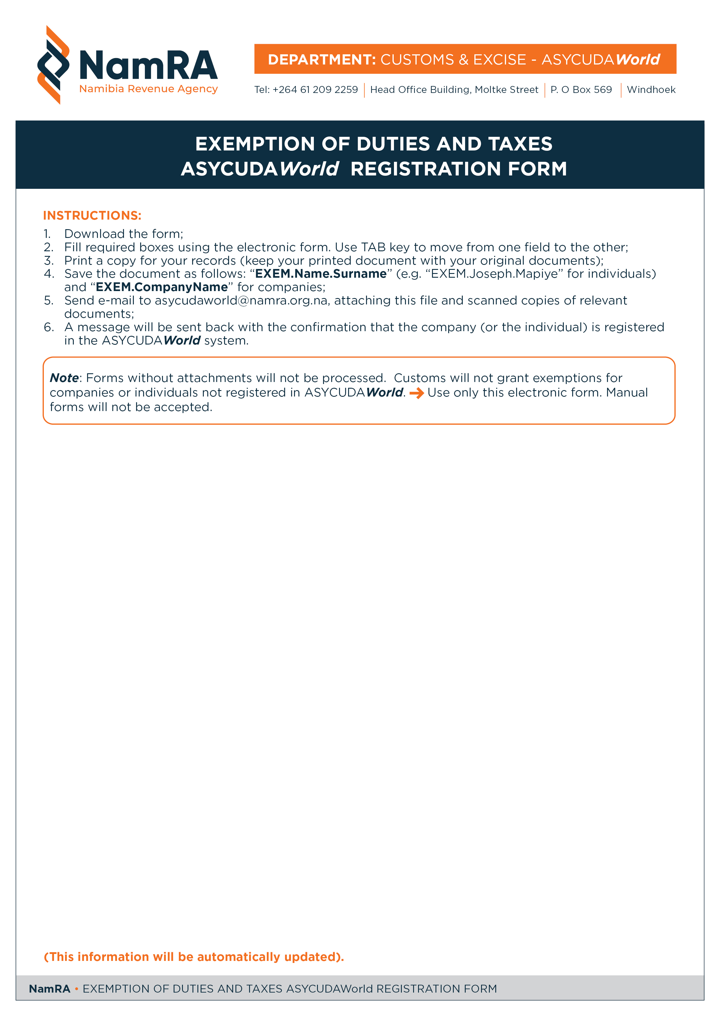
Form AWEXEM.001

PLEASE FILL THE FOLLOWING INFORMATION
NAME
POSTAL ADDRESS
ADDRESS (LINE 1)
ADDRESS (TOWN)
TELEPHONE NUMBER
MOBILE PHONE NUMBER
E-MAIL ADDRESS | @
CONTACT PERSON
PLEASE SELECT RELEVANT OPTIONS
DOCUMENT | Attached | Not Attached
Copy of Exemption Letter
Copy of TIN
Other
FOR OFFICIAL USE ONLY
REGISTRATION CODE |  | VALID FROM | VALID TO | OFFICE
EXEM | 000001 | 01/01/2014
Date/Time of print: 26/11/2013 - 11:31 AM

